

P
art
-
A

1
.
Wh
at is HTML?

A.

HTML

is a standar
d

language

us
ed
to
create and structure web pages
.

2
.Why was HTML introduced?

A. HTML was introduced to create and display web pages on the internet.
3.what is the full form of HTML?
A.HTML stands for Hypertext Markup Language.
4.Who introduced HTML?
A.HTML was introduced IN 1991 by
Tim Berners -lee
FIRST VERSION:HTML 1.0
5.Write a short note on this history of HTML?
















A. HTML was created by Tim BernersLee in 1991 to create and share web pages. It has been improved through different versions and is now widely used to build websites.
6.What is the purpose of <!DOCTYPE html>?



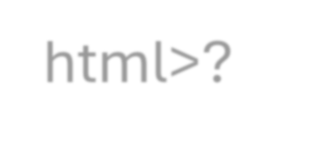











A. <!DOCTYPE html> is used to tell the web browser that the HTML document follows the HTML5 standard. It helps the browser display the webpage correctly.
7.Explain the basic structure of an HTML document.
A. BASIC STRUCTURE OF AN HTML DOCUMENT
An HTML document mainly contains.
1.<!DOCTYPE html>- Defines the document as HTML5.
2.<html>- The root element of the webpage.
3.<head> - Contains page information like title and metadata.
4.<body>- Contains the visible content of the webpage.
8.What is the difference b/w <head> and <body>?








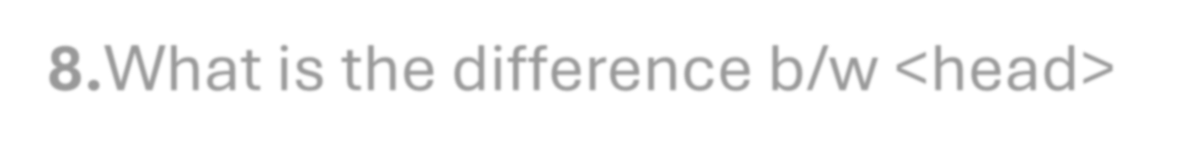





A. <head> contains information about the webpage that is not directly displayed, such as the title and metadata.














<body> contains the visible content of the webpage, such as text, images, links, and buttons.
9.What is an HTML Tag?
A. An HTML tag is a special keyword used to define and structure content on a webpage.
Example: <p> is used to create a paragraph.
10.What is the difference b/w opening and closing tags?
A. Opening tag starts an HTML element, while the closing tag ends it.
Example: <p> is the opening tag and </p> is the closing tag.

Part-B




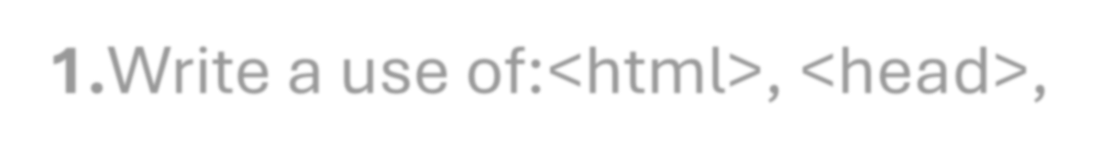
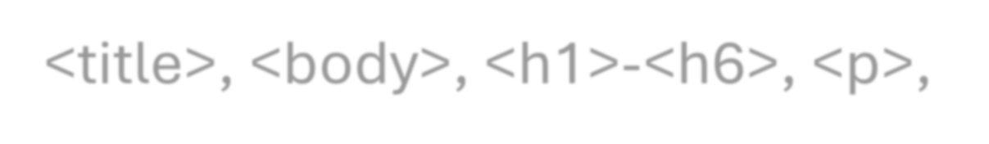
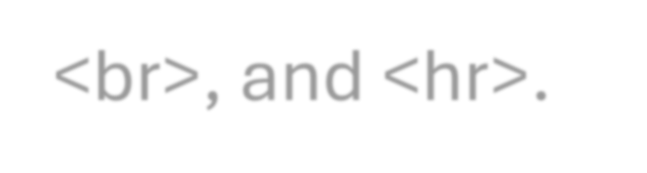





1.Write a use of:<html>, <head>, <title>, <body>, <h1>-<h6>, <p>, <br>, and <hr>.
A. a.<html>-Defines the HTML document.
b.<head>-Contains webpages information.
c.<title>-Sets the webpage information.
d.<body>-Contains visible webpage content.
e.<h1>-<h6>-Creates headings of different sizes.
f.<p>-Create a paragraph.
g.<b r>-Adds a line break.
i. <h r>-Creates a horizontal line.










2.Write an HTML program to display your name, college name, course and city.



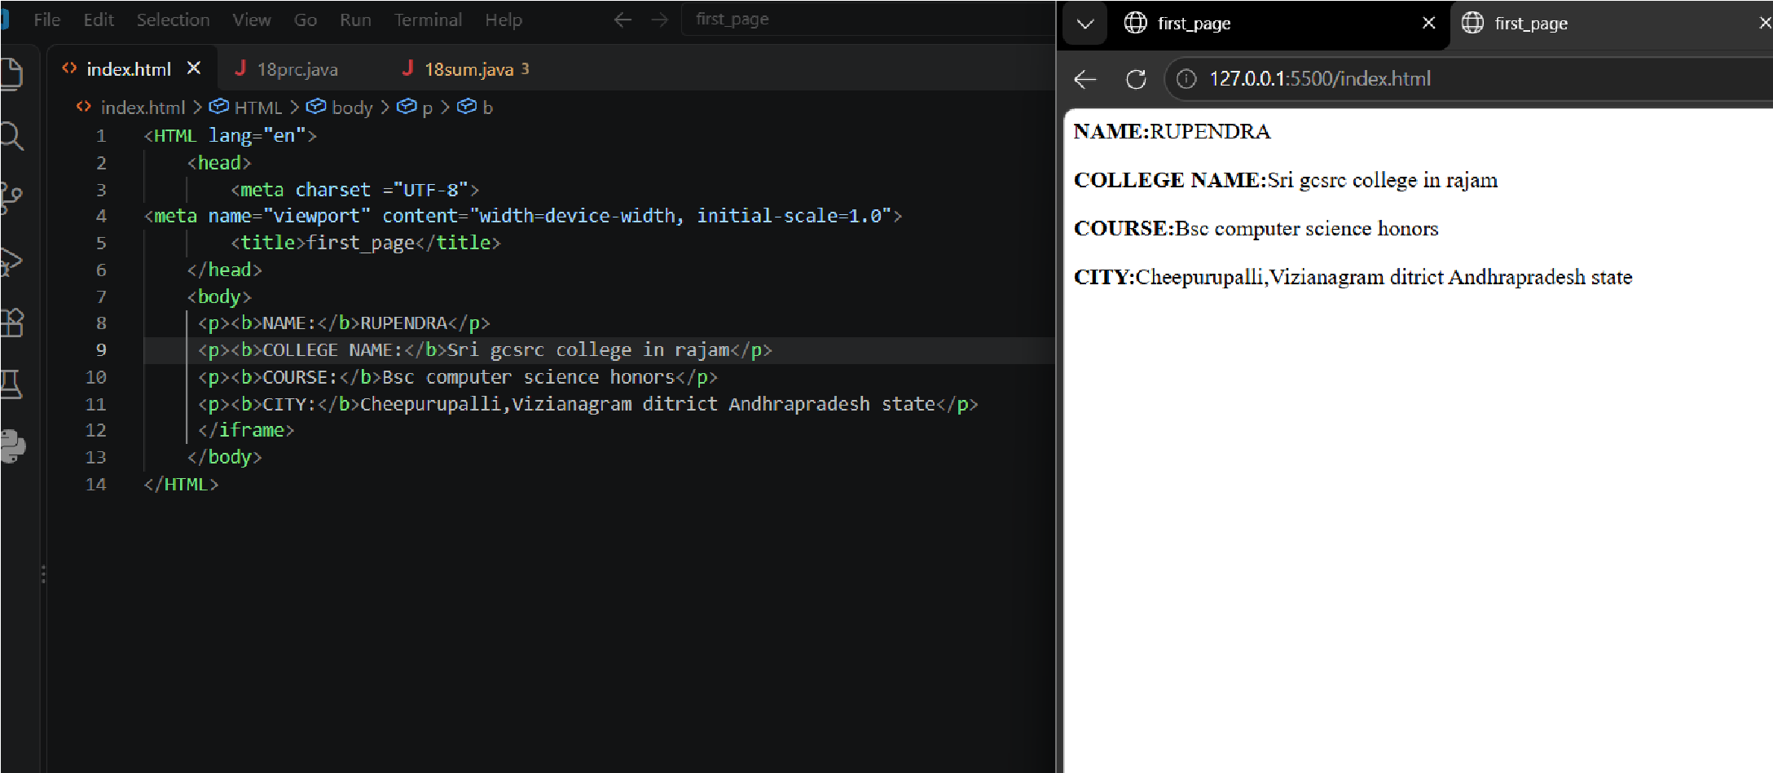
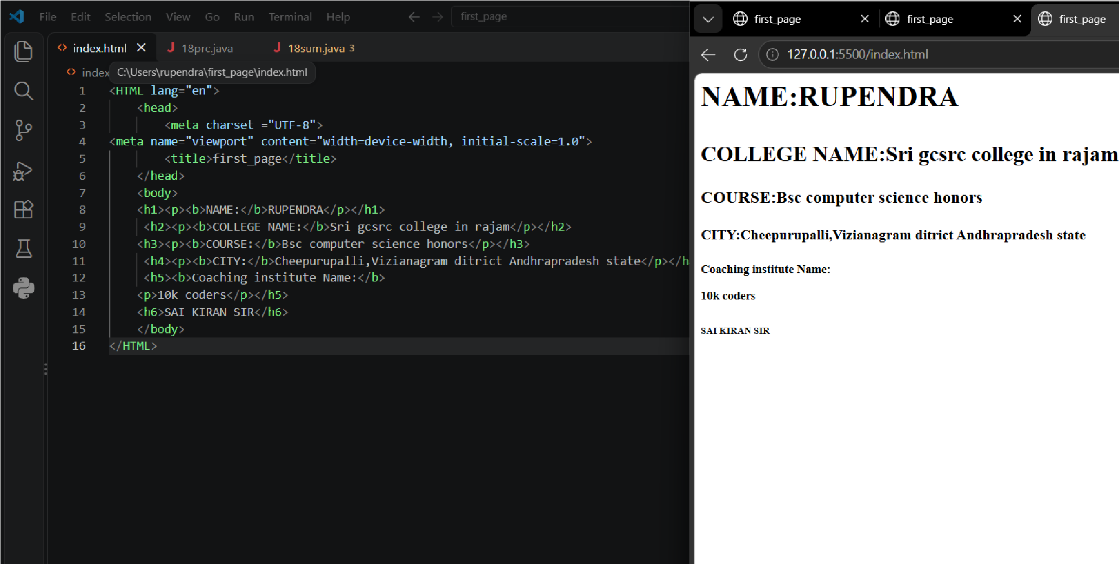
3.
Crea
te a web us
ing all
six heading
tags (<h1> to <h6>).






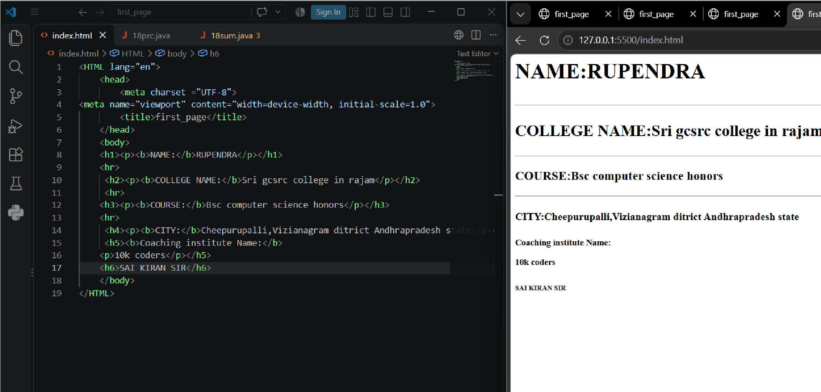
4
.Create a web
page contain
ing three
paragr
ap
hs with line horiz
o
nta
l

line
b
/w them.

5.
create a web page displa
y the
y
ou

t
ube video

?



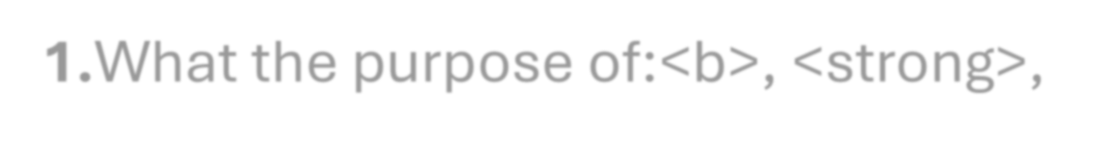
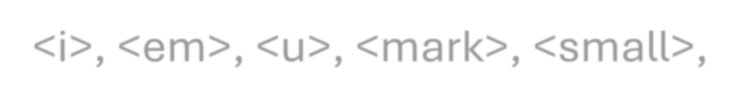
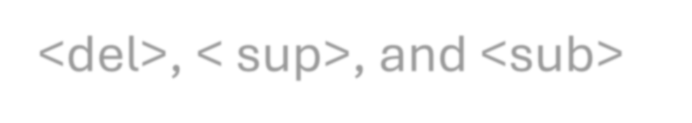



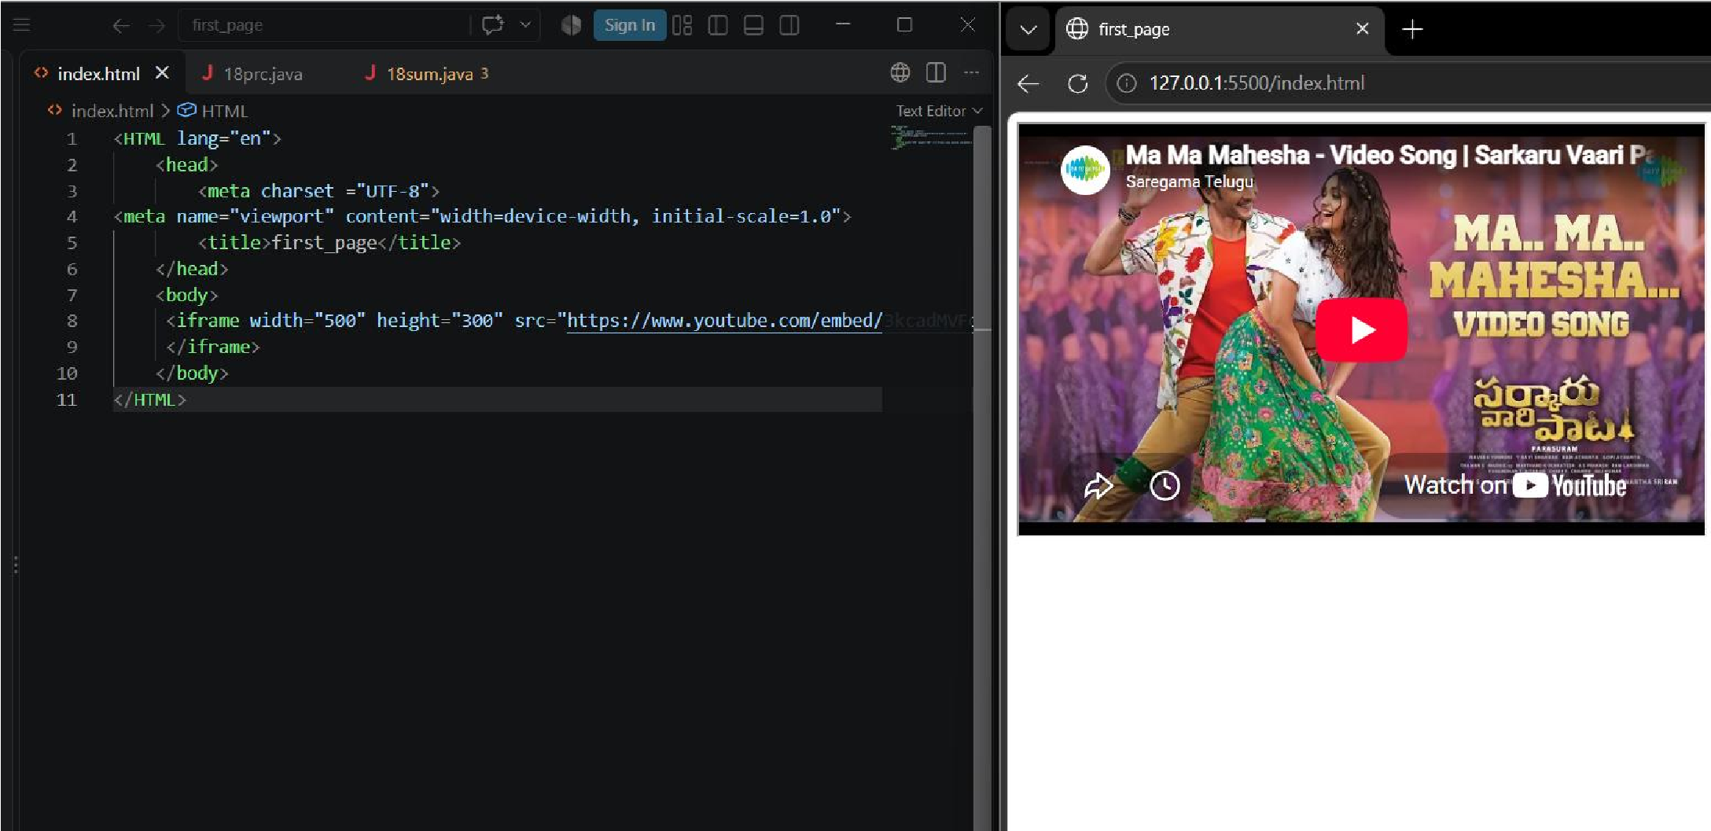

PA
RT
-
C

1.
Wh
at the purpose of
:<
b>, <strong>,
<
i
>
, <em>
,

<
u
>
,
<
mar
k
,
>
<
small>,
<
del>,

sup>, and <su
<
b>

A
.
<
b
>

–

Makes text
bold
.

<
strong
>

–

Shows
important text

(
usually bold).

<i> – Makes text italic.
<em> – Emphasizes text (usually italic).
<u> – Underlines text.
<mark> – Highlights text.
<small> – Displays smaller text.
<del> – Shows deleted text with a line through it.
<sup> – Displays superscript text.
< sub> – Displays subscript text.



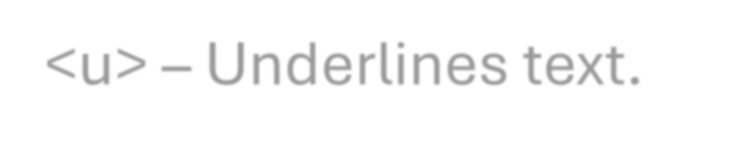









2.Create a webpage showing your name using bold, italic, and underline formatting.



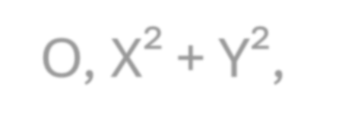



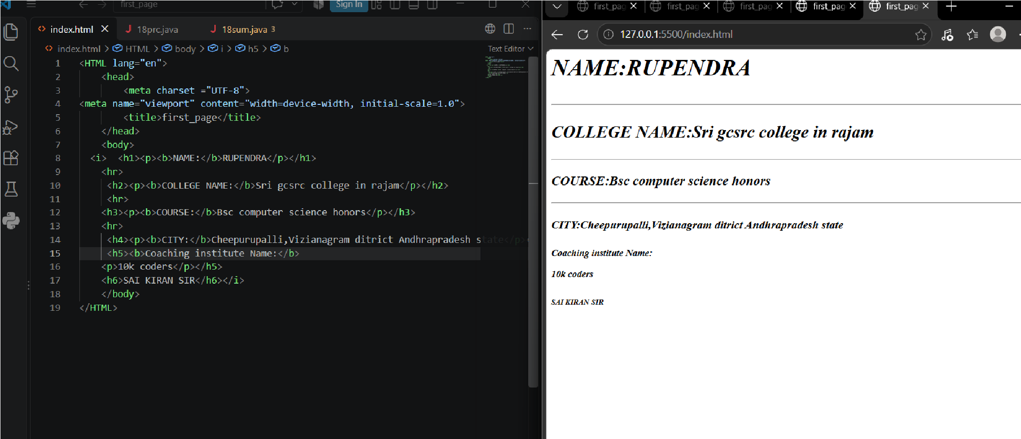
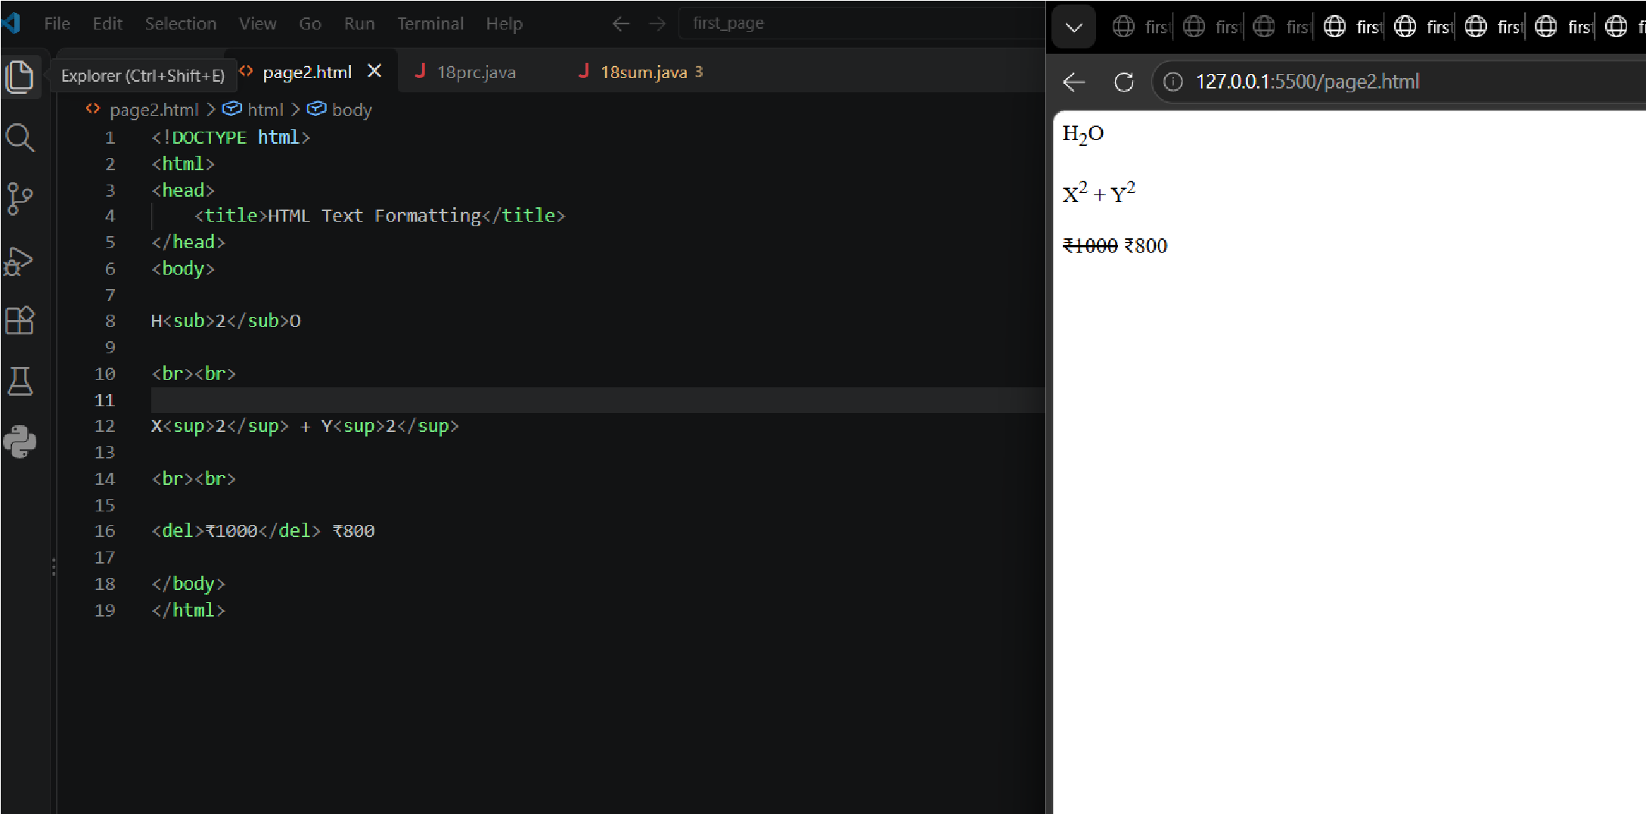
3
.

Write HTML to display H
■
O, X
²

+
Y
²
,
and
■
1000
as deleted price with
■
800
as current price
.

PART-D
1.What is a hyperlink?










A. A hyperlink is a clickable link that takes you to another webpage, website, or location.
2.Which HTML tag is used to create a link?
A. The <a> (anchor) tag is used to create a hyperlink in HTML.
3.Create a link to Google.


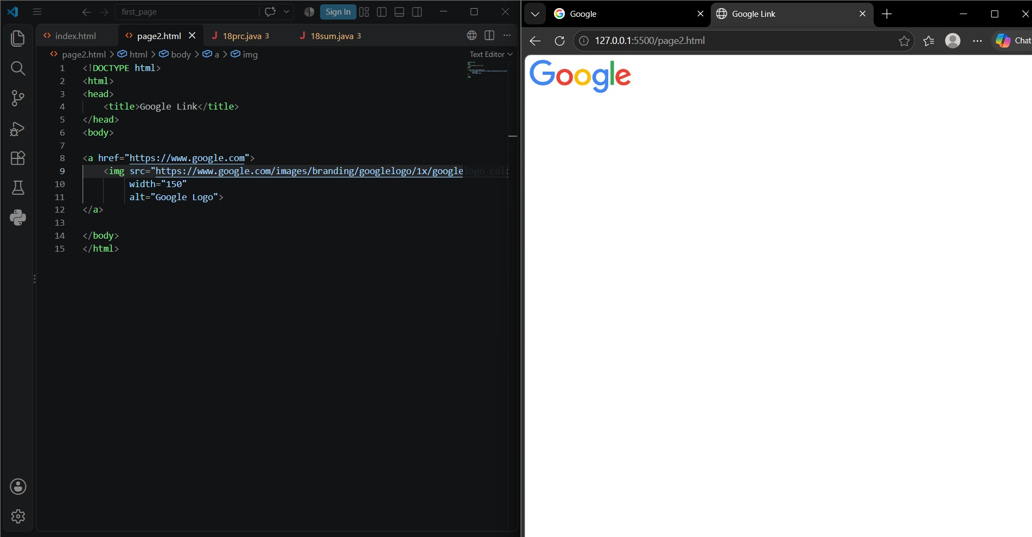
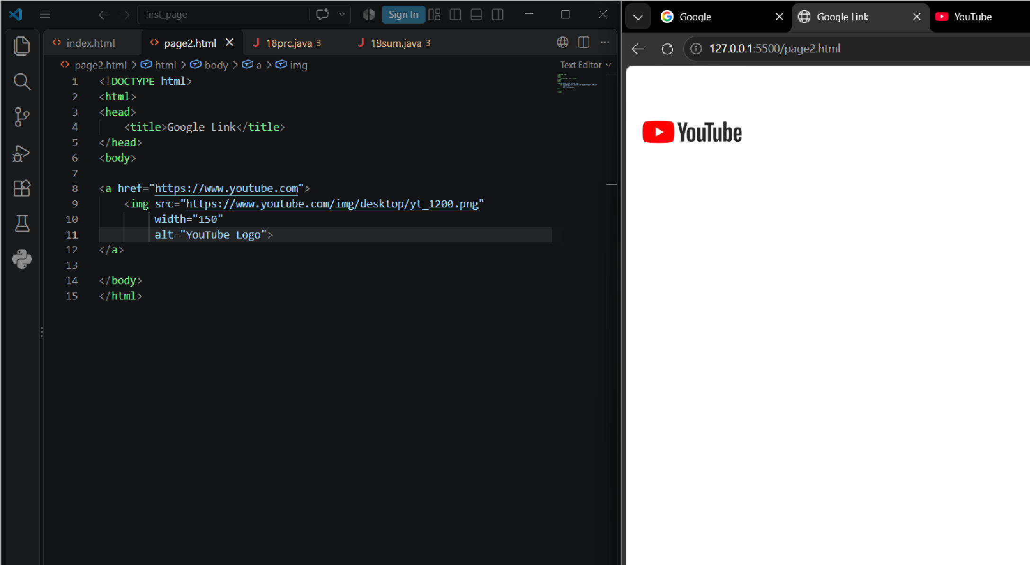

5
.
Create a link to you

tube.






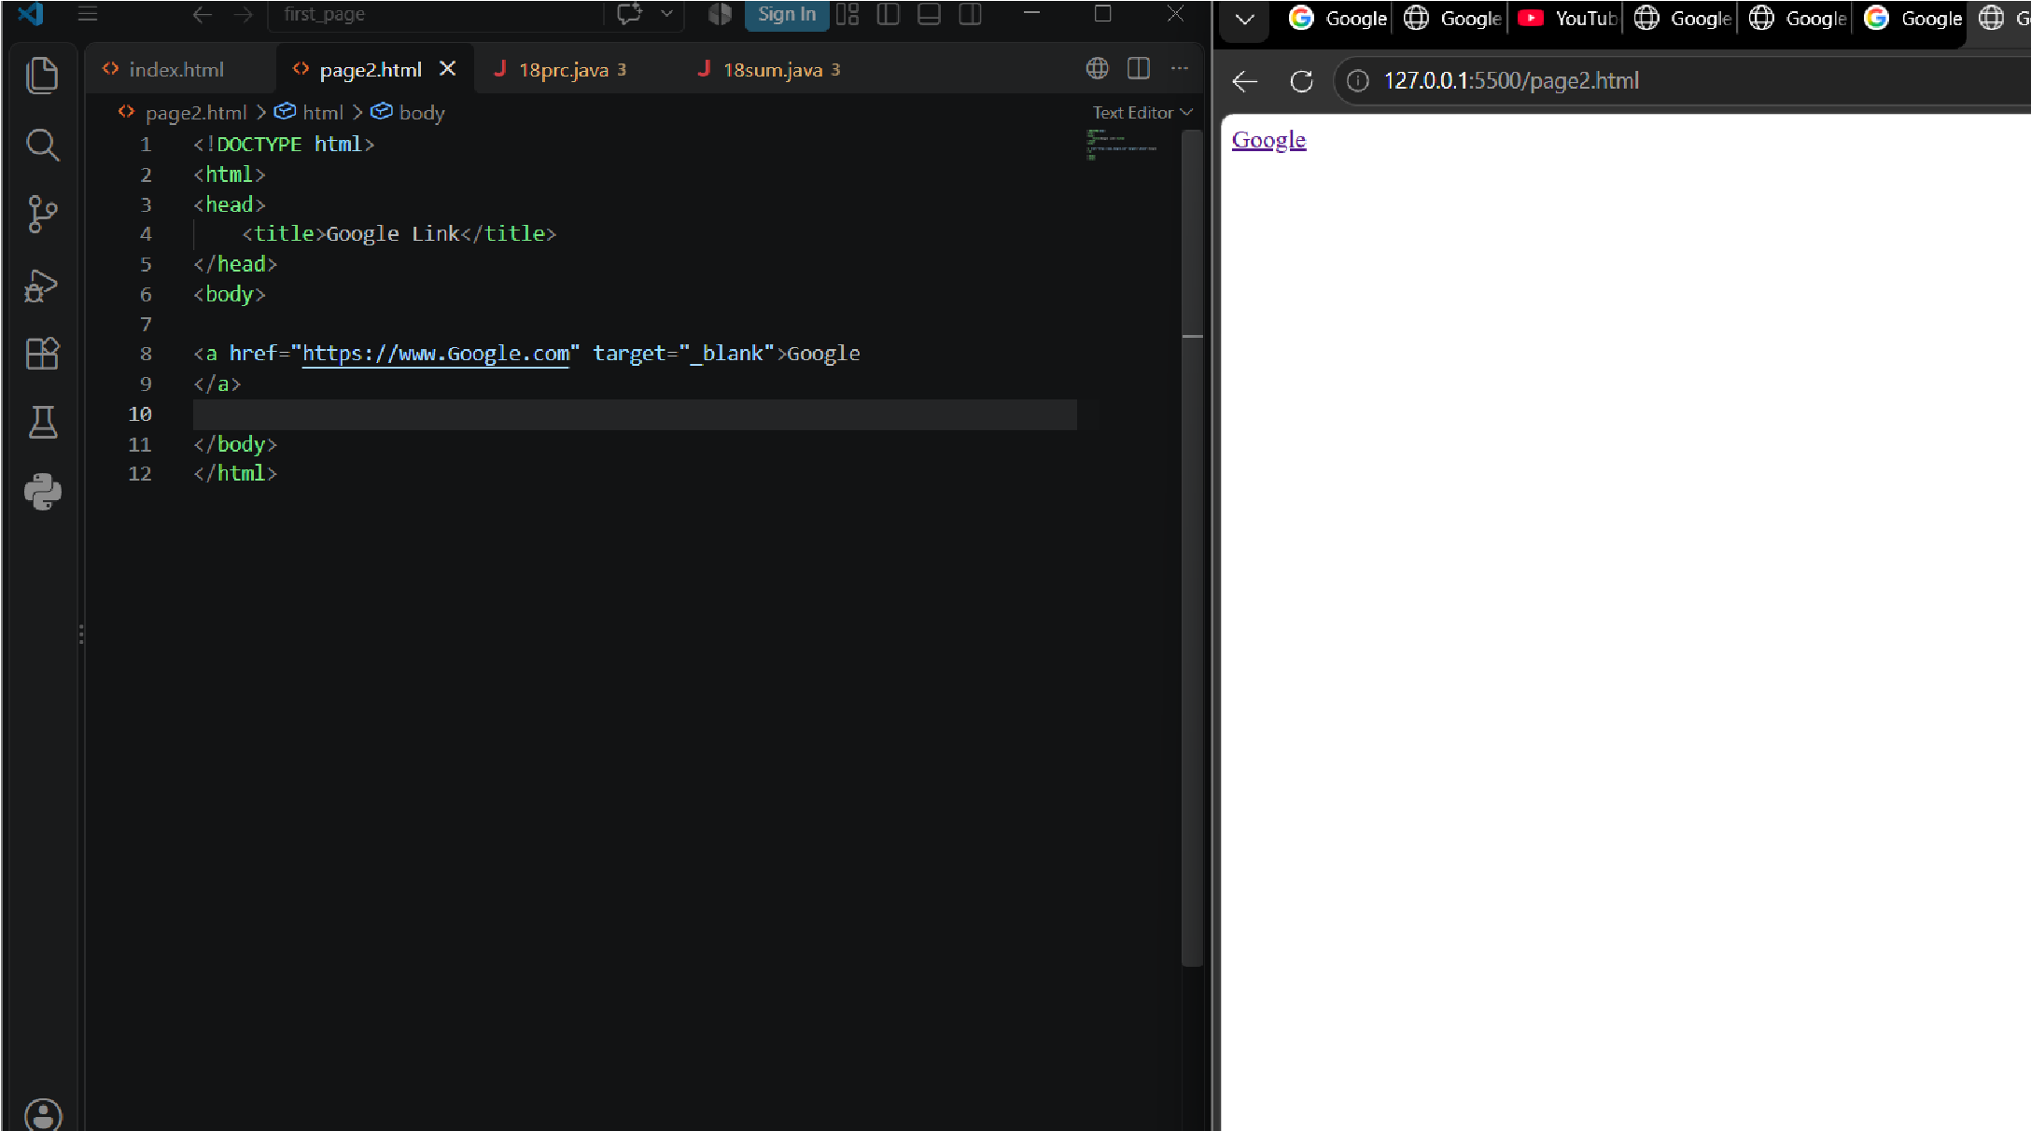
6.
Create

a

link tha
t opens in

a new
ta
b.

7.
Creat
e a webpage with links to

Goog
le,

YOUTUBE
,

and your colle
ge

web
sit
e.

